SAGE Research Methods Use-Case Scenarios
Case 1: Undergraduate researcher

Researcher: Adam, Undergraduate, Sociology major
Research project topic: Explore how people in different cultures share good and bad news with each other
Approach: The professor has asked that all students incorporate conversation analysis into their research projects
Methodology: Qualitative research
How SAGE Research Methods can help:
- Learning background information about conversation analysis as a methodological approach
- Understanding the differences between conversation analysis and discourse analysis
- Branching out (through the Methods Map) to learn about transcripts and their relationship to conversation analysis
- Viewing examples of conversation analysis being used in current research
- Go to www.srmo.sagepub.com and search “conversation analysis”
- Scroll down the list of results to show our first glance results and content type (book chapters, books, little green books, etc.)
- On the right hand side, refine your results to “encyclopedias” (remember, Adam is an undergrad and wants to understand the basics before moving on) and click “go”
- Mouse over a few of the abstracts, browsing the contents, and then click on the first result, Lewis-Beck, et al’s SAGE Encyclopedia of Social Science Research Methods
- Show book chapter, encyclopedia information, table of contents
- Scroll down to show complete chapter is there
- Scroll over the cite, print, download tools
Print, cite, email, and download tools

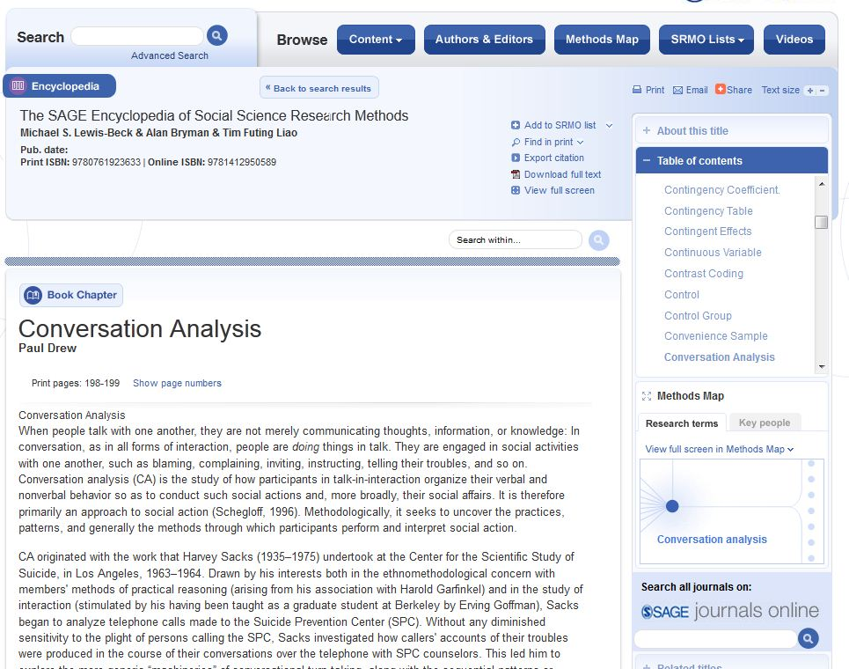
Button identifies you are in a book chapter
Button identifies you are in an encylopedia
Full-text HTML display of chapter
Table of contents
- Adam is just beginning his project and doesn’t have time to read all the background information about the origins of conversation analysis, but he decides to print a copy to read between classes and add the entry to a list
- Click print and show the HTML print format, complete with accurate page number and citation information, then go back to encyclopedia entry page
- On the encyclopedia entry page, click “Add to SRMO List” at top of screen and choose the option “Add Chapter”
- If you’re not already signed in, you’ll either need to sign in with your account
- Create a new list called “Conversation Analysis”
- Now head back to the encyclopedia page and click the back button to return to your search results
- Un-tick “Encyclopedias” and click the “Go” button get the full search results list
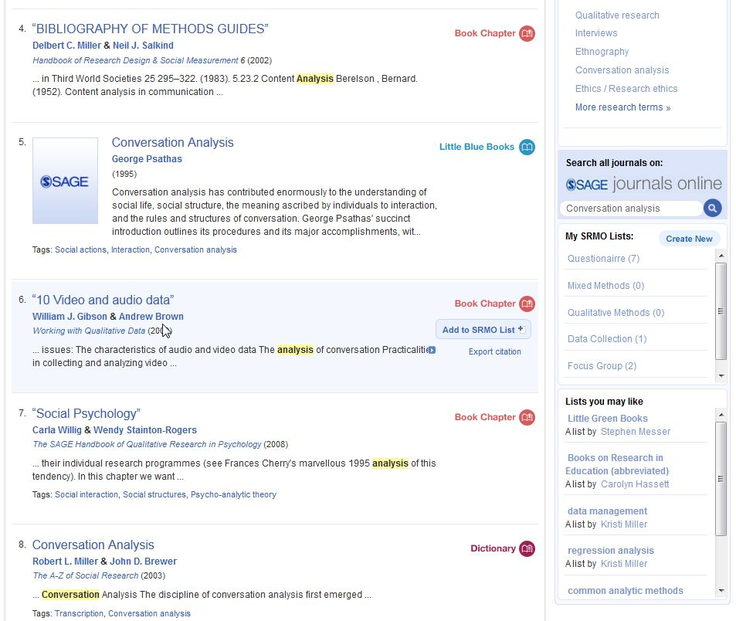
- Adam scrolls down the search results page to see what else he can find and notices a search widget for SAGE Journals. Click the search button to view journal article results for the term “conversation analysis” on the SAGE Journals platform

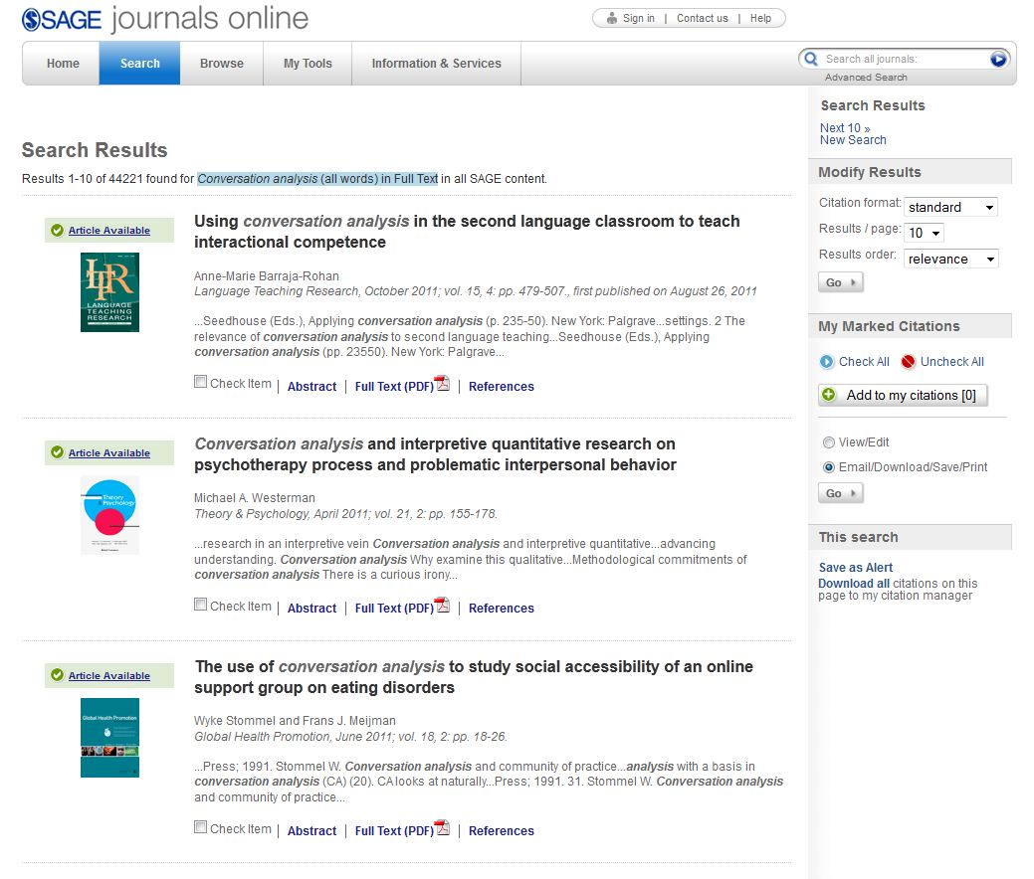

- Adam thinks these journal articles could be really useful, but returns to the SAGE Research Methods platform to learn more about practical ways to use conversation analysis in his research. He isn’t sure what else is available on the tool, so he decides to explore the Methods Map to get some ideas.
- On the right hand side of the search results page, click on the mini Methods Map
- “Conversation Analysis” pulls up as the center node
- Adam notices that “Transcripts” are a subset of “Conversation Analysis” and wants to learn more about using transcripts in his research
- Click on “Transcripts” and then expand the “Show Content” button
- Click on the red “Books” link
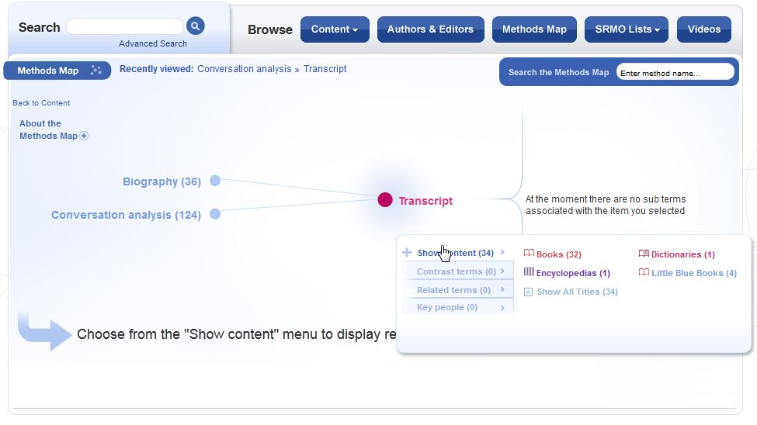
- Adam adds several search results to his Methods List so he can refer to them later; he simply clicks the “Add to list” button next to the relevant search results. The Little Blue Book “The Four-Step Method of Inquiry” and book chapter on “Transcribing interviews” will be practical and useful resources to teach him how to proceed with his research project

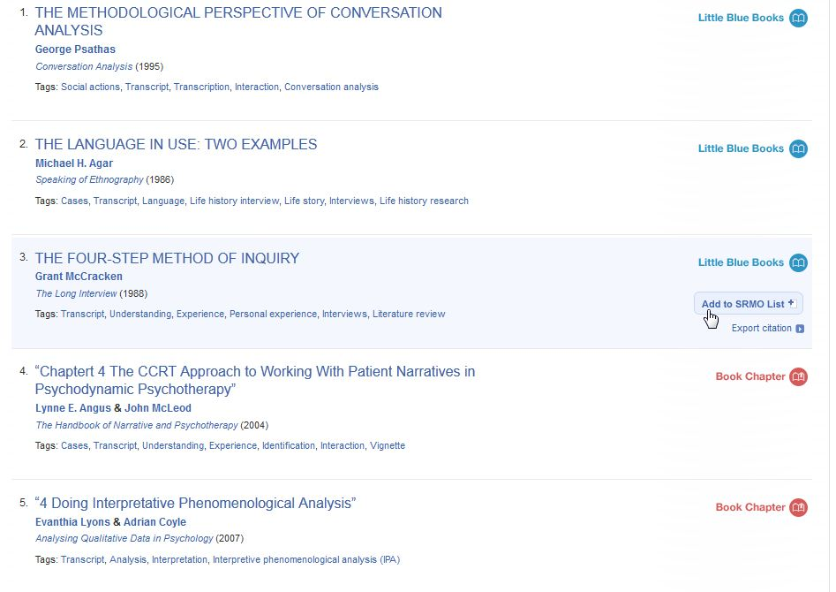

- Adam has decided to use conversation analysis and transcripts to identify patterns in sharing good news vs. bad news to better understand social life in different cultures

Case 2: Graduate researcher

Researcher: Jane, Masters of Public Health (MPH) candidate

Research project topic: Violence against women in India

Approach: Exploring the extent to which domestic violence is a contributor to physical and mental ill health of women in rural India and suggesting an effective response to the problem, despite cultural norms and attitudes that promote acceptance of violence against women

Methodology: Mixed methods

Focus groups, interviews, and questionnaires among married women age 18-35 years old in rural India

Quantitative study of women’s health and domestic violence from the World Health Organization

Summary of current laws in India that protect women from domestic violence and abuse

How SAGE Research Methods can help:
- General information on mixed methods research
- Administering a focus group
- Writing up research collected from the focus group, interviews, and questionnaires
- Jane knows she wants to use a focus group as part of her research, and wants tips on administering a focus group
- Go to www.srmo.sagepub.com and type in “focus groups” in the quick search box
- Scroll down the list of results to show our first glance results and content types
- Click on the book “Developing Focus Group Research”
- Show book chapter, basic information, table of contents
- Scroll down to show complete chapter is there
- As Jane scrolls down to read the introductory chapter, she notices a section on “Combining focus groups with quantitative methods” – knowing that she also wants to use a questionnaire as a quantitative method in her research, she thinks this book could be very useful in planning her research
- Click the “Back to top” button to go to the top of the page to take advantage of print, and download tools
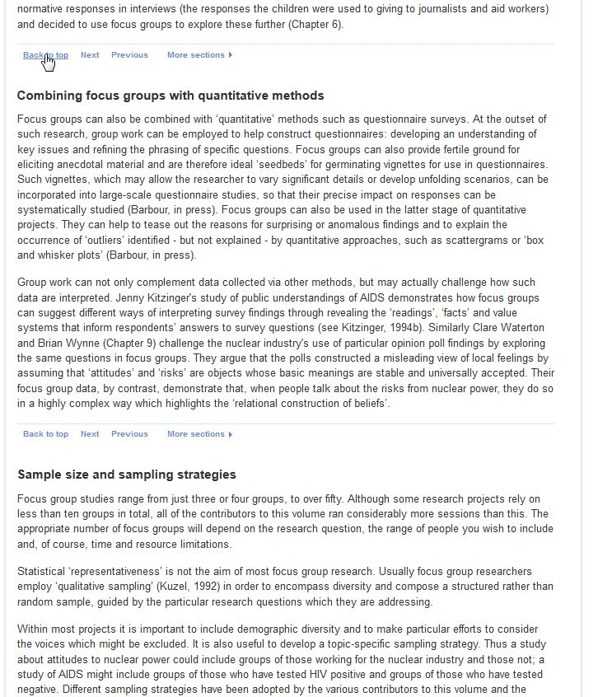

- As she gets back to the top of the page, Jane sees the full table of contents on the right-hand side of the page and notices relevant chapters on sensitive topics, feminist research, and meaningful participation in social research.
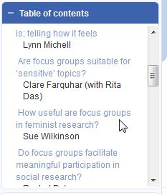
- With so many relevant topics, Jane decides to add the entire book to her Methods List, click the “add to SRMO List” drop down and click the “Add book” link
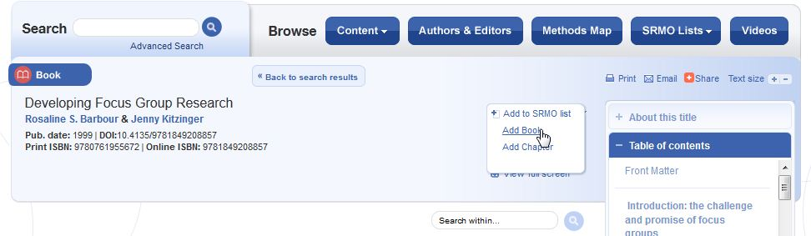

- If you’re not already signed in, you’ll need to sign in with your account
- Now Jane wants to find some information on questionnaires, so she types “questionnaire” in the quick search box at the top of the page.

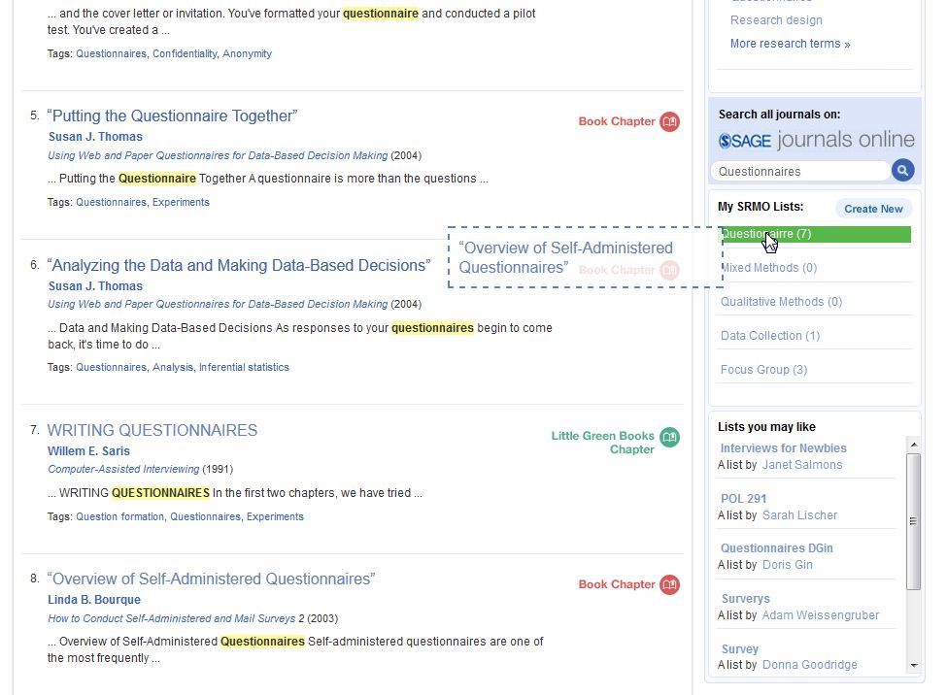
She uses the new “drag & drop” feature to drag relevant search results into her Methods List on questionnaires

With SAGE Research Methods, Jane know she has access to resources that will give her background information and practical ways to implement qualitative (focus groups) and quantitative methods (questionnaires) in her research project on violence against women in rural India

