Step One: Log into your account and select “Members” on the left side of your homepage, under the “My Bookshare” heading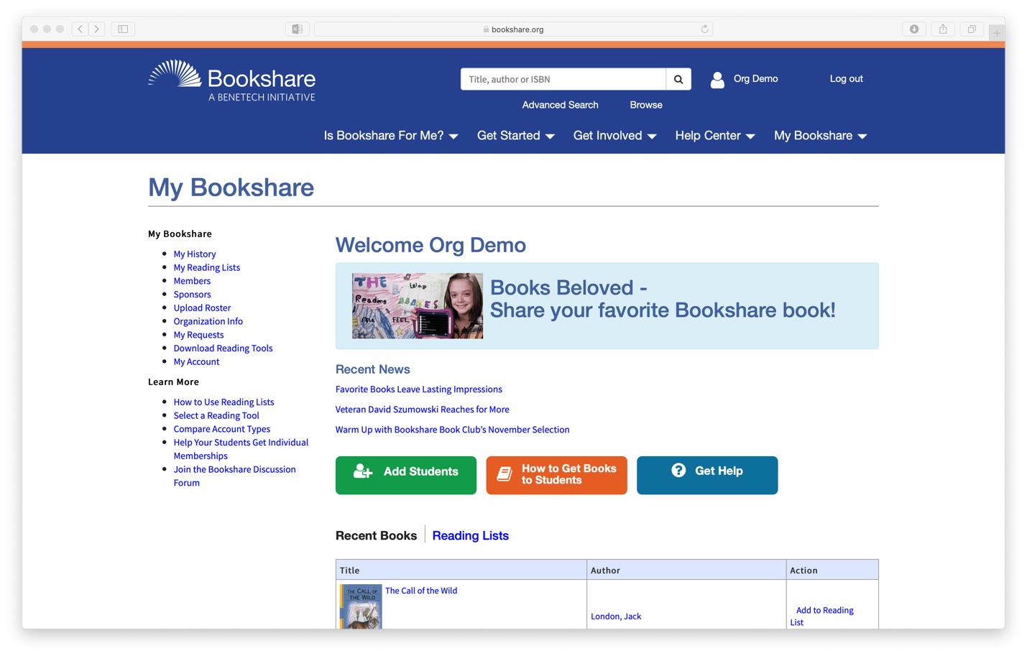
Click Here

Step Two: Select the members you would like to change. For a single member, click their last name and skip to Step Four. To change multiple members, select the checkboxes on the left.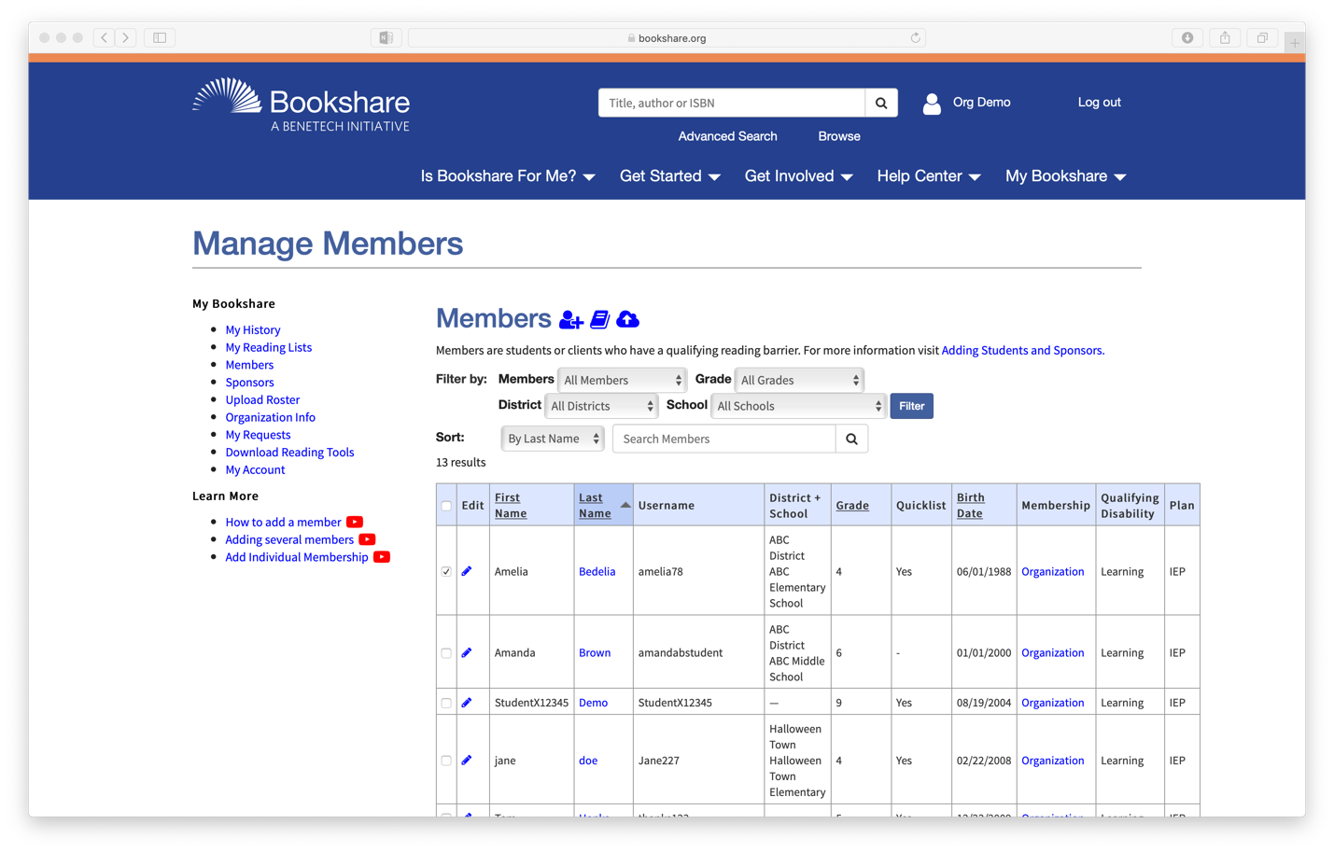
Change just one member here
Change multiple members here

Step Three: Once you have selected your students, scroll to the bottom of the page and click the More Actions dropdown menu. Then click the Add Individual Membership option.
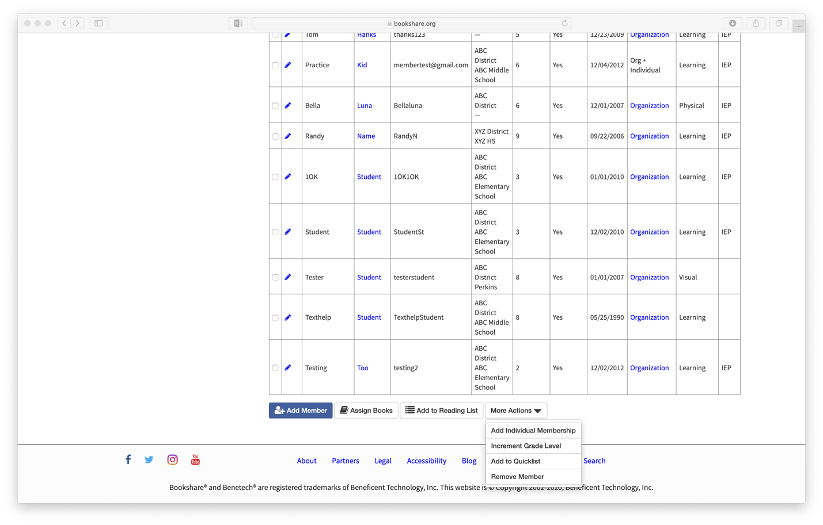
Click here

Step Four: Enter the member’s email address, and click Submit. The member will receive an email that will prompt them to set up their account and password.
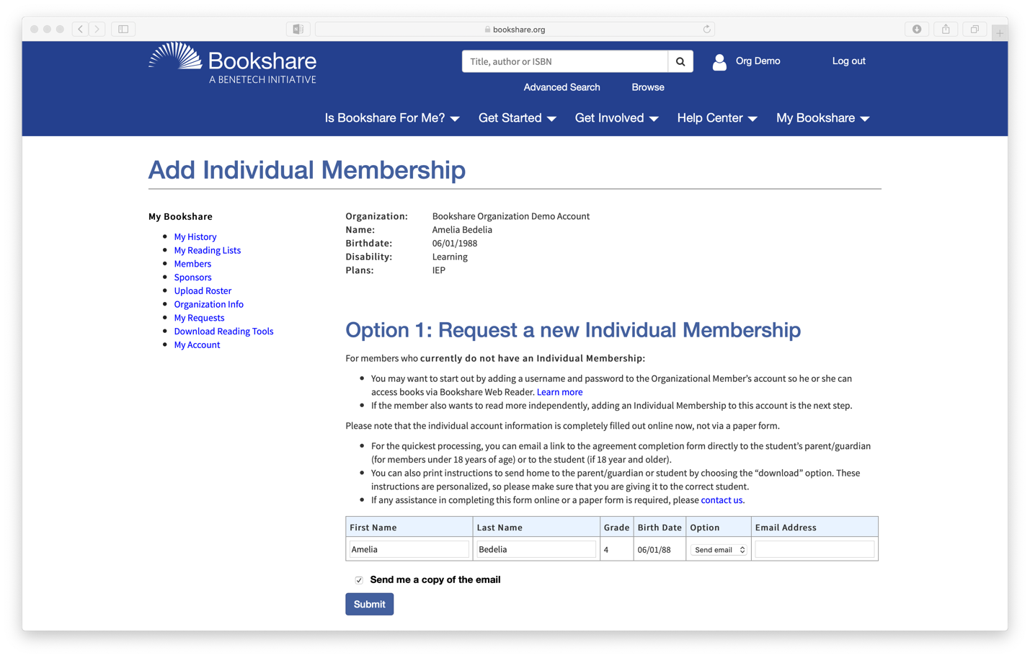
Then click Submit
Enter the member’s email address here

