Student Process
Step One: The students will get an Activation ID and link in their email. Once the students click on the link, they will be taken to this page, where they will input the ID and basic information and set their login password. 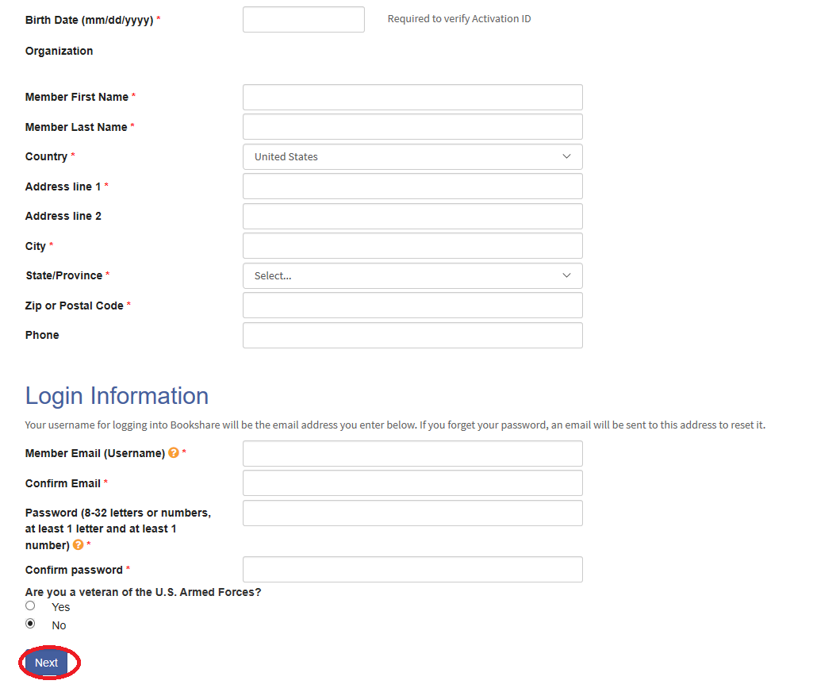
The member’s email will also be their username
Very important: make sure their birth date is the same as in the organizational account

Step Two: The student should select “Allow Teachers or Staff at my school or district to manage my account”. This will allow you, the account administrator, to help them reset their password and assign books if they need extra help.
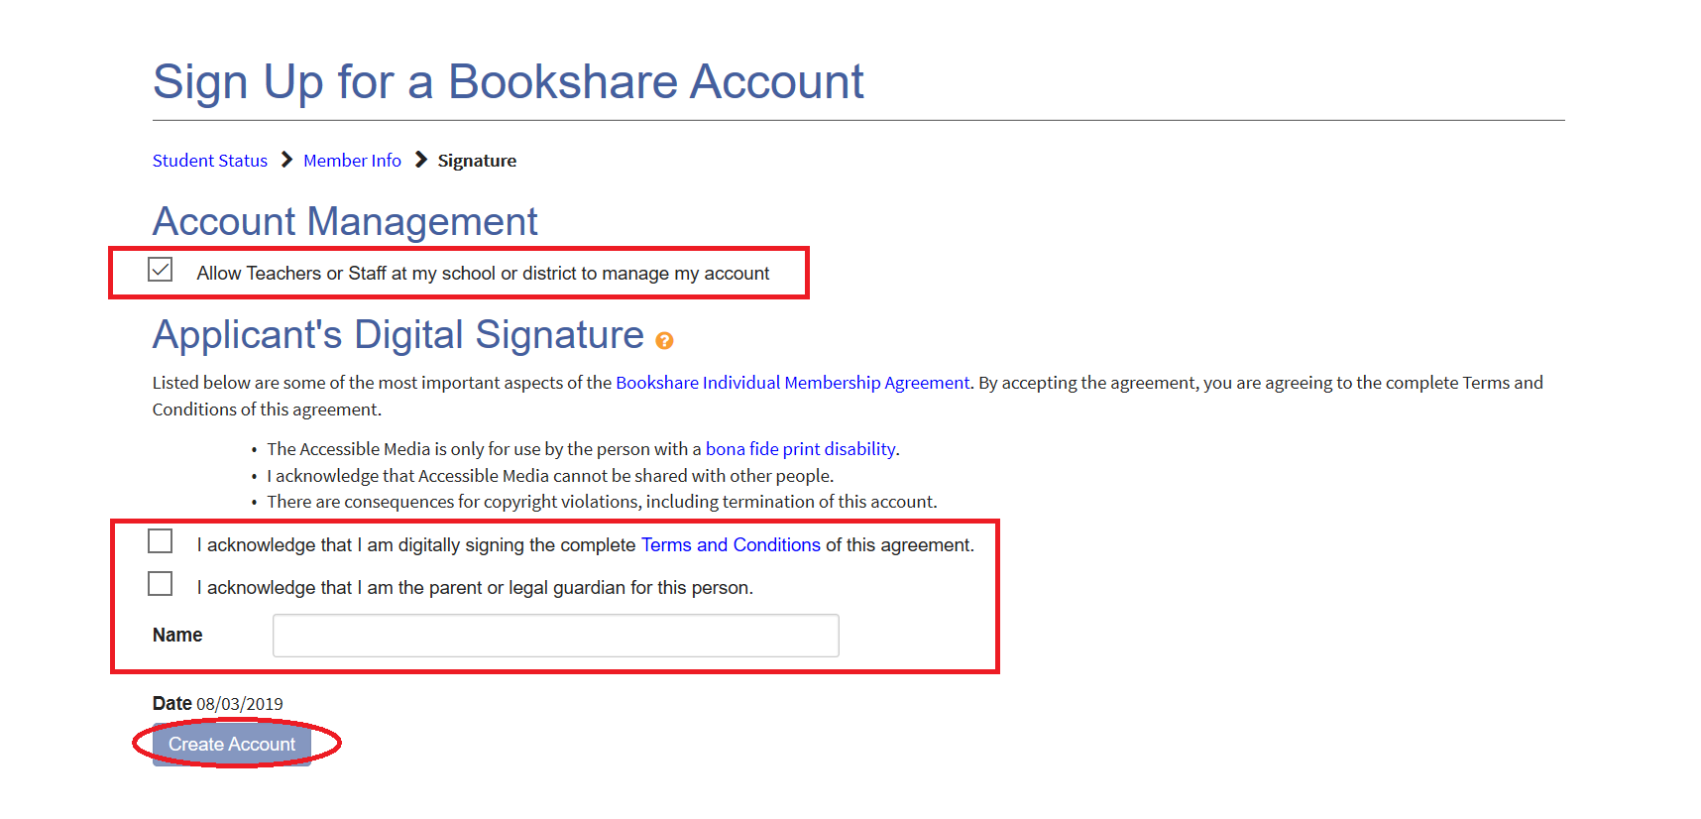
If the student is over 18, they can check the box for the “parent or legal guardian” themselves.
The student must agree to the terms and conditions.
This box should be checked, so you can help the member if needed.

