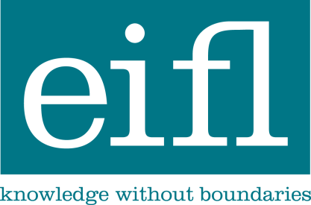

How to create effective marketing materials
about innovative public library services

Guide for grantee libraries of the EIFL Public Library Innovation Programme (EIFL-PLIP)

Marketing materials can serve a variety of purposes from promoting a public library service event to disseminating programme results and best practices. Below are tips for creating effective marketing materials for your public library service.

A sample of types of marketing materials includes

- Posters
- Brochures
- Signs
- “Give-a-way” (e.g., pencils, bookmarks, t-shirts)
- Advertisements and Public Service Announcements (PSAs)

Things to keep in mind when you are developing materials

Keep it simple

The first rule to remember when creating attention-getting materials is to keep them simple. You want people to notice and read them – less is usually more when it comes to marketing materials.

- Use easy-to-read fonts—a font is the size and style of a particular typeface.
  - Put the most important information in your marketing materials in the largest font and use smaller font sizes for additional information
  - Keep font families as consistent as possible rather than using multiple fonts. Use different weights or sizes of a font to add emphasis without adding visual confusion to your overall layout.
    - For example, the font used in this document called Ariel. The headline at the top of this document is Ariel 14 (size) and the rest of the document is Ariel 10.5.
- Use photos, but not too many or it will be distracting. Ideally, try and use one really great photo for a marketing piece
- Do not use too many colors
- Do not use patterns
- Do not include too much information

Focus on the most important information you want people to know

Always assume that your audience doesn’t have time to read everything you have to say. Tell them what they need to know quickly and clearly, and let them know how to find out more information about your service.

- Know who you are writing for and keep their preferences in mind as you write
- Use compelling headlines that attract attention and get your point across
- Tell the most important aspects of your story in one or two sentences
- Include a call to action—make it clear what you want people to do or think as a result of reading the information you present

When promoting events, always include a date, location and contact information and a website and/or phone number people can call for more information. If you are using social media, you can also include this information in your materials as well.

Establish a visual focus for your readers

Most people are very visual. When you are developing marketing materials, consider using photos or illustrations to capture a reader’s attention and help communicate your service story.

- Make sure to use a photo or illustration that connects to your service purpose and message. Photos should be good quality (also known as high resolution) otherwise they may appear blurry or grainy in printed materials. 300dpi is the suggested resolution for printing the clearest image. If you do not have photos, you can choose photos from iStock (istockphoto.com) on the Internet. Clip art is also available online for free or at low-cost.
- If you have the resources, it is worth the investment to hire a professional photograph to take photographs at an event and/or other visual examples of your service so you will have a set of photos you can use for multiple purposes including marketing materials, website, social media and traditional media.
- A few quick tips when you are using visual images:
  - Place your strongest image in the top half of the page where it will get the best visibility.
  - Using one large picture makes a stronger impression than several smaller ones.
  - Alternatively, if you want to use multiple photos on the same page, group them together so they collectively form a single visual element.

Finalize and proof all materials

When your materials are close to completion, take a few final steps to ensure they’re effective.

- Have someone who has not been involved in the development of the materials give them a read-through and copyedit. A quick check list:
  - Does the content make sense – is the main message clear?
  - Is it grammatically correct?
  - Is it attractive and does the formatting look right?
- Double check phone numbers and website URLs. When possible, “test” the materials with a few members of your target audience and solicit their feedback.
- Periodically review and update your materials to give them a fresh look and to ensure they reflect recent developments.

